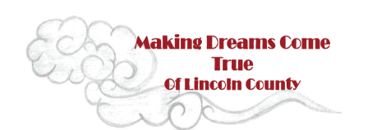
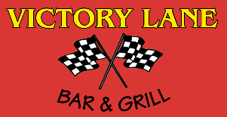
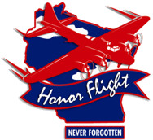

Victory Lane 13th Annual Fund Raising Golf Outing

Benefitting Making Dreams Come True of Lincoln County, a new
Organization formed to make a difference for Community members suffering from a severe hardship

Saturday August 26th, 2017 at Merrill Golf Course

Sponsorship Information
Hole in 1 Corporate Sponsor $1000 / ($700 without golf team)
- Banner recognition (with name and logo) at Merrill Golf Course and Victory Lane, also on all official golf outing signs, and any marketing related to the event
- Company Logo in the golf outing pamphlet.
- Sponsored golf team (Four People). ( $320 Value)
- Making Dreams Come True Golf Shirts for your golf team
- Participate in delivering the “dream” to this year’s recipient(s) as well as delivering check to Honor Flight coordinator.

Double Eagle ($700)/($550 without golf team)
- Banner recognition (with name and logo) at Merrill Golf Course and Victory Lane, also on all official golf outing signs, and any marketing related to the event
- Company Logo in the golf outing pamphlet.
- Sponsored ½ golf team ( Two People) ( $160 value)
- Numerous plugs at the golf course and at Victory Lane.

Eagle ($350 - Beverage Cart. Only 2 available) – ( $350- $5,000 Hole in One Sponsor)
- Banner recognition (with name and logo)
- Hole in One or Beverage Cart Sponsorship
- Large signage for the hole in one sponsorship at a par 3 hole
- Or Signage on one of the two beverage carts
- Company name in golf outing pamphlet

Birdie ($150)
- Signage (with Company name and logo) at your sponsored hole.
- Banner recognition (with name).
- Company Name in golf outing pamphlet

Sponsorship deadline is August 1, 2017

Thank You for Your Support!

