MARATHON COUNTY SHERIFF’S DEPARTMENT
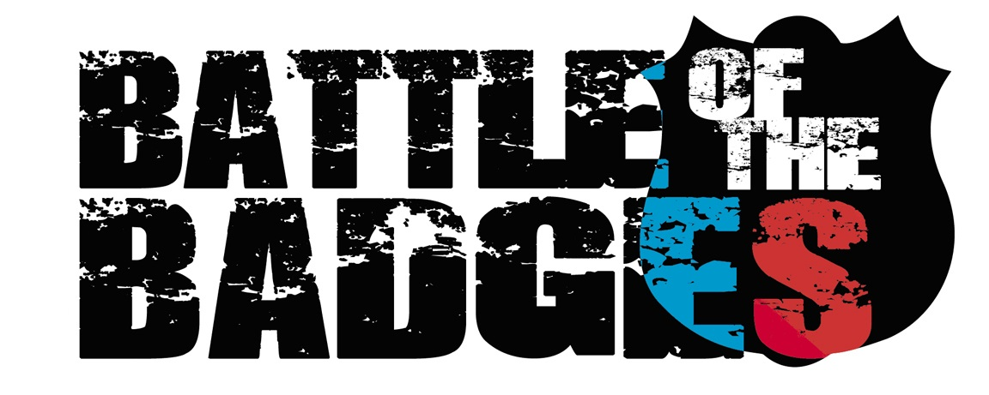
IS HOSTING IT’S 2ND ANNUAL

SOFTBALL TOURNAMENT
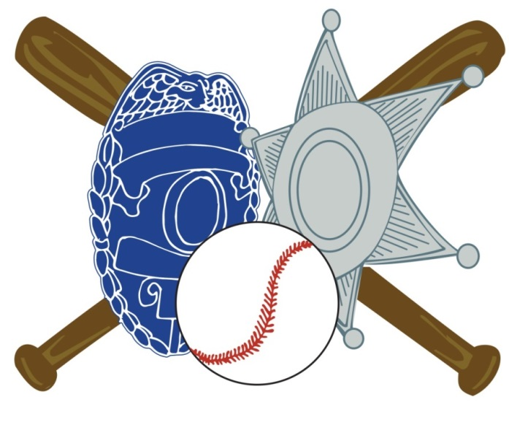

SEPTEMBER 18th & 19th, 2015
SUNNYVALE PARK – WAUSAU
ALL PROCEEDS WILL BENEFIT ‘NEVER FORGOTTEN HONOR FLIGHT’!
- LAST YEAR WE RAISED $4,000! LET’S DO IT AGAIN!
- CONCESSIONS AVAILABLE THROUGH BOY SCOUT TROOP 438
- RAFFLES WILL BE GOING ON THROUGHOUT THE TOURNAMENT!
- COME OUT AND SUPPORT YOUR LOCAL LAW ENFORCEMENT OR FIRE TEAM
FOR A FUN FILLED WEEKEND OF SOFTBALL!
CONTACT INFO: HANNAH.BECKER@CO.MARATHON.WI.US

