7th Annual
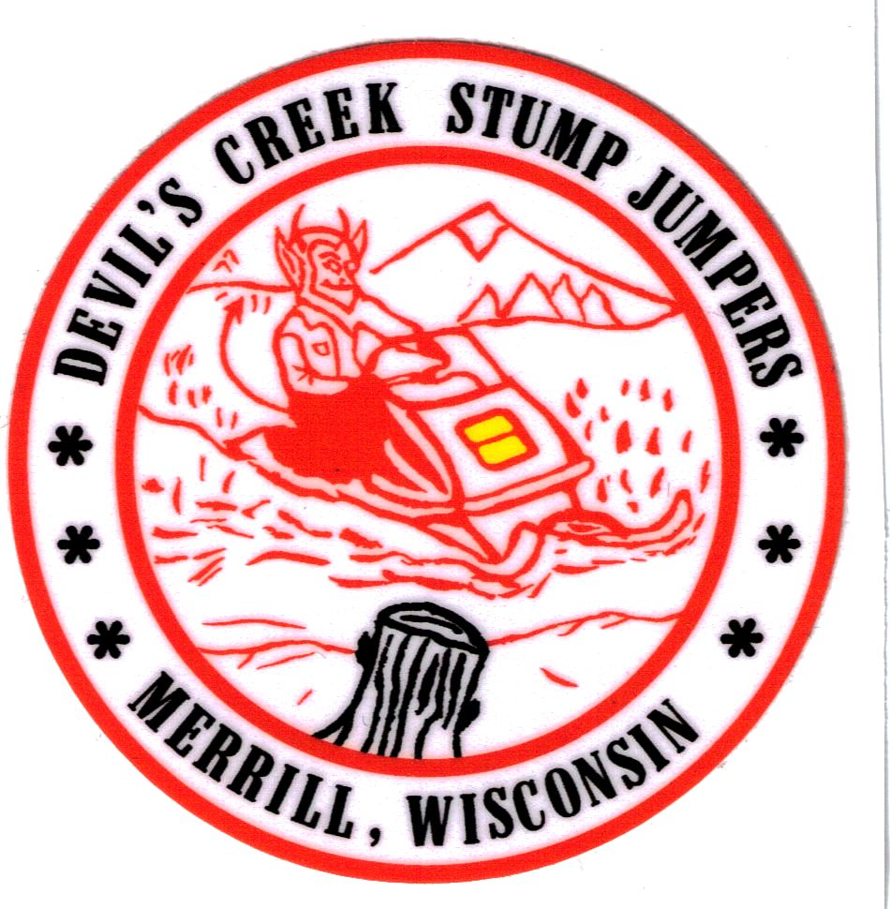
Devil’s Creek Stump Jumpers
Vintage Snowmobile Show & Ride
Saturday February 14, 2015
Held at Schult’s Country Inn – W5931 Church Ave. Merrill, WI 54452
Fun & Food - Chili & Hotdogs
1971 Sno-Prince XL-300 Snowmobile Raffle
Win it for $2 a ticket
Money raised will be Donated to Honor Flight – Merrill Area Veteran
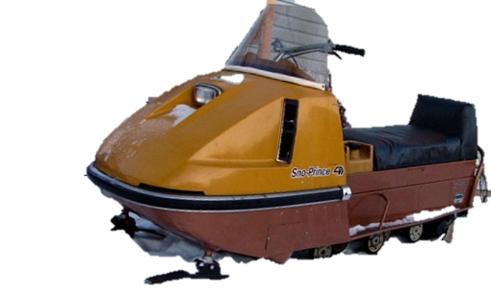

Awards for 1st & 2nd in Orig. & Restored to 1990
Many Unique Awards Also
Registration at 8:30-12:00
$5 Per Sled, $20 Max
Free Admission for Spectators
Participant Judging & Judges Awards at 2:30
Vintage Clothing & One–Pull-Start Contest
Door Prizes & Raffles
Trail Ride 3:30 (trails permitting)
Info: 715-551-1796 or at www.devilscreek.org

